EduTrack: Intelligent University Academic Platform
Project Based Learning (PBL) · Advanced Data Structures & Algorithms · Project Documentation
Field | Details
Project Title | EduTrack: Intelligent University Academic Platform
Use Case | An academic data platform with six algorithm modules (M1 to M6), one per course outcome (Advanced level; Strings · Suffix Structures · DP · Network Flow · NP-Completeness · Randomized & Parallel)
Course | Advanced Data Structures & Algorithms, [Course Code]
Programme / Year | B Tech, II Year
Section | 1
Academic Year | 2026–27
Faculty / Mentor | Dr. Maganti Syamala
Department | CSE

Team Members
S.No. | Student Name | Roll No. | Individual Role / Contribution
1 | Hemanth Reddy | 2500030702 | M1 string algorithms and M2 suffix structures; document-search and indexing design (CO-1, CO-2)
2 | Ram Naresh | 2500032071 | M4 network flow and allocation; system architecture and module integration (CO-4)
3 | Ramya | 2500030673 | M3 advanced DP (edit distance, bitmask DP); test cases, benchmarking and documentation (CO-3)
4 | Yogitha | 2500030904 | M5 NP-completeness and scheduling; M6 randomized and parallel analytics (CO-5, CO-6)

Index
- Updated Problem Statement and Objectives
- Final System Architecture
- Module Description
- Implementation Details
- DSA Concepts Used
- Testing Methodology and Test Results
- Debugging Details
- Performance and Optimization
- Final Results
- Individual Contribution of Each Team Member
- Limitations and Future Enhancements
- References
Appendix: Supporting Evidence · Final Submission Checklist

1. Updated Problem Statement and Objectives

1.1 Problem Statement
A university holds thousands of student and faculty records, courses, assignments, examination records, learning documents, timetables and a continuous stream of student activity data. Searching, matching and allocating these with simple methods becomes slow and error-prone as the data grows. A linear scan reads all the text for every search, and one typo in a query finds nothing. Manual or greedy allocation of faculty, rooms and exam slots produces clashes with no guarantee that a feasible plan exists. One-by-one analytics over millions of activity records is slow and uses too much memory.
EduTrack addresses this by pairing every academic task with a purpose-built algorithm. The platform groups 28 advanced algorithms into six modules, so that fast retrieval, document indexing, record comparison, resource allocation, constraint processing and large-scale analytics each use the right technique. The guiding question of the project is: how do we make academic search, allocation and analytics fast, correct and scalable?

1.2 Objectives
- Search courses, queries and keywords fast, using KMP, Z-function, Rabin-Karp and Aho-Corasick (M1).
- Index academic documents with suffix arrays, SA-IS, LCP/Kasai, suffix trees and automata, and detect repeated phrases across assignments (M2).
- Correct queries and optimize processing using Levenshtein and Damerau-Levenshtein distance, matrix-chain, bitmask DP and optimal BST (M3).
- Allocate faculty, classrooms and resources using bipartite matching and maximum flow (M4).
- Model examination and scheduling constraints as SAT and vertex-cover problems and handle them with reductions and approximation (M5).
- Rank and summarise large student-activity data using randomized, streaming and parallel algorithms (M6).

1.3 Scope of the Project
In scope: string search over course names, keywords and codes; document indexing and repeated-phrase detection; typo-tolerant query correction; faculty-to-course matching and room/resource allocation by max-flow; exam-clash modelling with SAT and vertex-cover approximation; ranking, sampling and aggregation of activity data. These are delivered as a hand-built Java application with a 35-service console menu and a three-role web dashboard (Student, Faculty, Admin) over a 10,000-student dataset (EduTrack.csv), plus a Python reference script that verifies the core algorithms.
Out of scope: integration with a live university database, production-grade authentication and security, distributed deployment, and full coverage of every one of the 28 algorithms in the Python reference test suite (Section 6.1 states exactly which are executed).

2. Final System Architecture
EduTrack is a layered platform. Requests flow from users to services, services call the algorithm engine, and the engine reads the academic data store.
Layer | Components | Role
1. Users | Students, Faculty, Admin | Send search, allocation and report requests
2. Interfaces | Console menu (35 services in 8 groups); web dashboard with Student, Faculty and Admin portals | Where requests enter and results are shown
3. EduTrack services | Search, Similarity, Allocation, Scheduling, Analytics | A service picks the task to run
4. Algorithm engine ("EduTrack Engine, Pure DSA") | M1 Strings, M2 Suffix, M3 DP, M4 Flow, M5 NP, M6 Randomized & Parallel, hand-built in Java | Runs the right module for the task
5. Academic data store | Records (EduTrack.csv, 10,000 students), Documents, Schedules, Activity | Holds the data the modules read
Figure 2.1: Layered architecture of EduTrack (users, services, algorithm engine, data store). Answers, plans and reports return to the users along the same path.

2.1 Architecture Explanation
The flow has five steps. (1) Students, faculty and admins send requests. (2) A service decides which task is needed: Search, Similarity, Allocation, Scheduling or Analytics. (3) The engine runs the matching module. (4) The module reads records, documents and activity data from the academic data store. (5) Answers, plans and reports go back to the users.
Each service is wired to one or two modules. Search uses M1 for exact keyword and course-code matching and M3 for typo correction. Similarity uses M2 suffix structures to flag repeated phrases across assignments. Allocation uses M4 matching and max-flow. Scheduling uses M5, which turns exam clashes into SAT and vertex-cover problems. Analytics uses M6 to rank records and aggregate streaming data in parallel. The modules do not call each other directly, so each can be tested and replaced on its own.
Users reach the services through two front ends that share the same engine: a 35-service console menu (Section 4.5) and a three-role web dashboard (Section 4.6).

2.2 Technology Stack
Category | Technology / Tool | Purpose | Version
Language | Java, hand-built data structures and algorithms (no java.util classes) | All six algorithm modules and the console application | [Java version]
Console interface | Text menu with 35 services; activity report per run (algorithm, category, input, time in ms, results) | Run any service and see the algorithm used | n/a
Web interface | Browser dashboard with Student, Faculty and Admin portals; Slate, Navy and Dark themes; opened from menu option 35 | Role-based views over the same engine | [web stack]
Dataset | EduTrack.csv, 10,000 student records | Data for search, analytics and allocation | n/a
Reference verification | Python 3 standard library (collections, bisect, random, time) | Independent assertion tests and benchmarks of 15 core algorithms | 3.12.3
Presentation | PowerPoint deck (EduTrack_Presentation_dsa.pptx) | Project review presentation | 14 slides

3. Module Description
EduTrack is organised into six algorithm modules, matched one-to-one with the course outcomes, plus a test and benchmark harness.
S.No. | Module | Purpose / Function | Key Algorithms | Student Responsible
1 | M1 String Algorithms (CO-1) | Fast search of course names, queries, keywords and codes | KMP, Z-Function, Rabin-Karp, Aho-Corasick | Hemanth Reddy
2 | M2 Suffix Structures (CO-2) | Index documents and find repeated phrases | Suffix Arrays, SA-IS, LCP/Kasai, Suffix Trees and Automata | Hemanth Reddy
3 | M3 Advanced DP (CO-3) | Correct queries and optimize processing | Levenshtein, Damerau-Levenshtein, Matrix-Chain, Bitmask DP, Optimal BST | Ramya
4 | M4 Network Flow (CO-4) | Allocate faculty, rooms and resources | Bipartite Matching, Ford-Fulkerson, Edmonds-Karp, Dinic, König's theorem | Ram Naresh
5 | M5 NP-Completeness (CO-5) | Model exam and scheduling constraints | SAT, 3-SAT to CLIQUE, CLIQUE to VERTEX-COVER, 2-approximation | Yogitha
6 | M6 Randomized & Parallel (CO-6) | Rank and summarise large activity data | Randomized QuickSort, Reservoir Sampling, Miller-Rabin, Blelloch Scan, Parallel Reduce, Brent's theorem | Yogitha
7 | Test & Benchmark Harness | Prove correctness and measure performance | Expected-output tests, timing script | Ramya

4. Implementation Details

4.1 Development Environment
EduTrack is written in Java with hand-built data structures and algorithms; every console report states "Hand-built, zero java.util.*". The application runs as a console menu and also opens a web dashboard from menu option 35. A separate Python 3.12.3 reference script (edutrack.py, about 250 lines) re-implements 15 core algorithms and compares each with a hand-verified expected value, using time.perf_counter for the benchmarks. Run commands: python3 edutrack.py for the reference script, and [add the Java build and run commands] for the application.

4.2 Core Module-I: Search and Query Correction (M1, M3)
Core Module-I combines exact string search with typo-tolerant matching (CO-1, CO-3). KMP precomputes a failure table so the pattern is never re-compared from scratch, which gives O(n + m) search over a text of length n and a pattern of length m. Rabin-Karp uses a rolling hash, so each shift costs O(1) on average, and a candidate is confirmed by direct comparison to rule out hash collisions. When a query returns nothing, Levenshtein distance finds the closest course names. Damerau-Levenshtein also counts a swap of two adjacent characters as one edit, which matches the way people actually mistype.
def kmp_search(t, p): # M1: O(n + m)
f = [0] * len(p); k = 0
for i in range(1, len(p)): # build failure table
while k and p[i] != p[k]: k = f[k-1]
if p[i] == p[k]: k += 1
f[i] = k
res = []; k = 0
for i, c in enumerate(t): # scan the text once
while k and c != p[k]: k = f[k-1]
if c == p[k]: k += 1
if k == len(p): res.append(i - k + 1); k = f[k-1]
return res
def lev(a, b): # M3: O(m * n) time, O(n) space
d = list(range(len(b) + 1))
for i in range(1, len(a) + 1):
prev = d[0]; d[0] = i
for j in range(1, len(b) + 1):
cur = d[j]
d[j] = min(d[j] + 1, d[j-1] + 1, prev + (a[i-1] != b[j-1]))
prev = cur
return d[-1]
Listing 4.1: KMP search and Levenshtein distance (rolling one-row table), Python reference version

4.3 Core Module-II: Allocation and Constraints (M4, M5)
Core Module-II contains the allocation and scheduling modules (CO-4, CO-5). Faculty-to-course assignment is a bipartite matching problem: faculty are on the left, courses on the right, and an edge means the faculty member is eligible. Room and resource allocation is modelled as a flow network with a source, capacity-limited edges and a sink, and Edmonds-Karp finds the maximum flow by repeatedly taking the shortest augmenting path found with BFS, which bounds the running time at O(V · E²). For exam scheduling, two exams that share a student are connected by an edge; the vertex-cover 2-approximation then picks both ends of every uncovered edge, which guarantees a cover of at most twice the optimum in O(V + E) time, because the problem itself is NP-complete.
def edmonds_karp(cap, s, t): # M4: O(V * E^2)
n = len(cap); flow = 0
while True:
par = [-1] * n; par[s] = s; q = deque([s])
while q and par[t] < 0: # BFS for shortest augmenting path
u = q.popleft()
for v in range(n):
if par[v] < 0 and cap[u][v] > 0: par[v] = u; q.append(v)
if par[t] < 0: return flow
b = 10**9; v = t
while v != s: b = min(b, cap[par[v]][v]); v = par[v]
v = t
while v != s: # push flow, update residual graph
cap[par[v]][v] -= b; cap[v][par[v]] += b; v = par[v]
flow += b
def vc2(edges): # M5: 2-approximation, O(V + E)
cov = set()
for u, v in edges:
if u not in cov and v not in cov: cov |= {u, v}
return cov
Listing 4.2: Edmonds-Karp max-flow and vertex-cover 2-approximation, Python reference version

4.4 Module Integration
A task travels through the platform in a fixed order. (1) Student and faculty records, documents, schedules and the activity stream are loaded into the data store. (2) A query arrives, and M1 string search and M3 edit distance find matches even when the query has typos. (3) Documents are indexed with M2 suffix structures, so repeated phrases across assignments are flagged. (4) M4 matching and max-flow assign faculty to eligible courses and rooms to classes. (5) M5 turns exam clashes into SAT and vertex-cover problems and produces a conflict-free plan or an approximate cover. (6) M6 ranks records and aggregates streaming student data in parallel for reports. Each module takes plain Python lists, strings and adjacency structures as input and returns plain results, so modules can be combined without shared state.

4.5 Console Interface: 35 Services
The console menu lists 35 numbered services in eight groups, plus 0 to exit. Each run prints an activity report that names the service, the algorithm used, its category, the text the user typed, the time taken in milliseconds and the results.
Group | Services | What the user can do | Closest module
Course & Syllabus Search | 1 to 4 | Search courses and syllabi by keyword; find repeated sentences in submissions; look up course codes; scan lecture material for syllabus vocabulary | M1
Digital Library & Plagiarism Checking | 5 to 8 | Search exact phrases in slides; build an index for textbooks; detect copied paragraphs; count word frequencies | M1, M2
Student Directory & Degree Planning | 9 to 17 | Typo-tolerant profile lookup and name correction; syllabus comparison; similar sections; fastest order for grade reports; faster lookup of popular courses; shortest walking route between lab buildings; degree prerequisites; elective enrolment tracking | M3 (9 to 14); graph services (15 to 17)
Multilingual Digital Repository | 18 | Browse reference articles in 8 regional languages | Text services
Campus Scheduling & Lab Allocation | 19 to 23 | Balance lab capacities; find registration and room bottlenecks; match students to lab stations; assign electives by preference; choose research projects within a budget | M4
Resource Optimization & Decision Making | 24 to 27 | Place security checkpoints; pack equipment into vans; find minimum supervising staff; solve exam timetabling and room conflicts | M5
High-Speed Data Auditing & Diagnostics | 28 to 32 | Verify ID-card security keys; sort large rosters; instant course lookup; random audit sample; parallel summary of grades | M6
System Controls | 33 to 35 | Guided showcase; self-test with automated diagnostics; web dashboard status and browser link | n/a
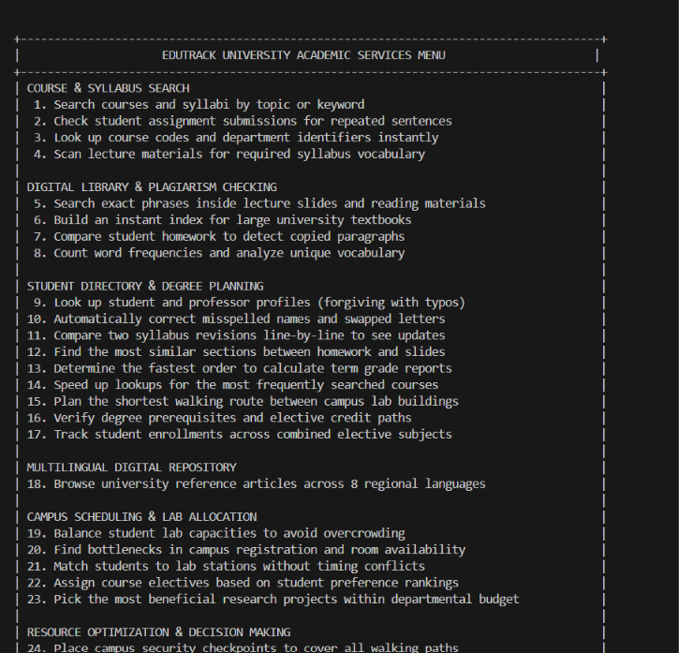
Figure 4.1: EduTrack console menu, groups 1 to 5 and the start of group 6 (services 1 to 24).
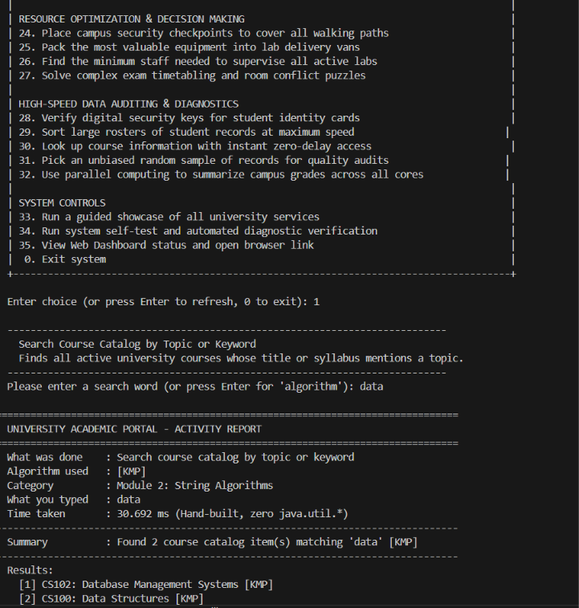
Figure 4.2: The rest of the menu (services 24 to 35) and service 1 searching the course catalog for "data". KMP found CS102 Database Management Systems and CS100 Data Structures in 30.692 ms. The report labels the category "Module 2: String Algorithms"; this document numbers it M1.

4.6 Web Dashboard
The web dashboard has three role portals that share one engine, shown at the bottom of each sidebar as "EduTrack Engine, 10,000 Records, Pure DSA". Every portal offers three themes (Slate, Navy, Dark), a global search over students, faculty and courses, and a role switch.
Role | What the portal shows | DSA features visible on screen
Student (Aarav Das, ET100072, CSE Year 4) | CGPA 8.03 on a 10-point scale; attendance 87.2%; latest exam score 85.1 (grade A); countdown and hall ticket for the next exam; 114 of 140 credits earned; registered courses | "Fast Search (DSA)" tagged KMP
Faculty (Dr. Rajesh Sharma, F101, CSE) | 3 assigned courses; 840 enrolled students; class attendance 82.4%; 14 submissions pending; early warning for 18 at-risk students (attendance below 75% or CGPA below 6.0) | Automated DSA filter for at-risk students; "Class Analytics & Matching" tagged Hopcroft
Admin (Dr. Alok Verma) | 10,000 students; 12 active courses; 10 faculty; pass rate 79.9% (7,990 students); average CGPA 7.14; average attendance 79.8%; student directory with create, read, update and delete | "Exam Timetable (DSA)" tagged Coloring; Dean's Honors Roll; analytics and logs
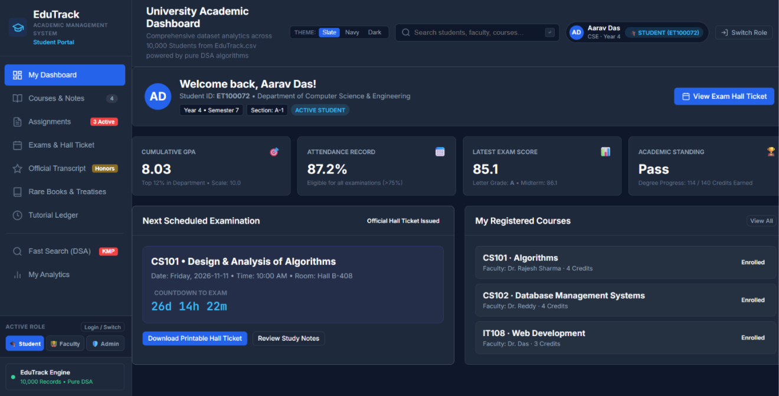
Figure 4.3: Student portal for Aarav Das: GPA, attendance, next exam and registered courses, with Fast Search (DSA) using KMP.
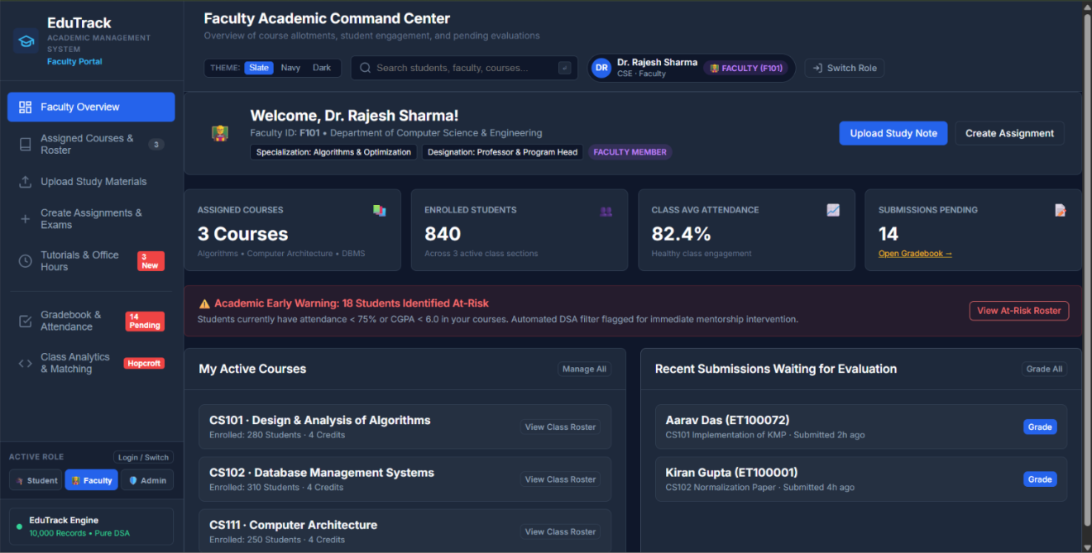
Figure 4.4: Faculty portal for Dr. Rajesh Sharma: assigned courses, pending submissions and the automated early-warning list of 18 at-risk students.
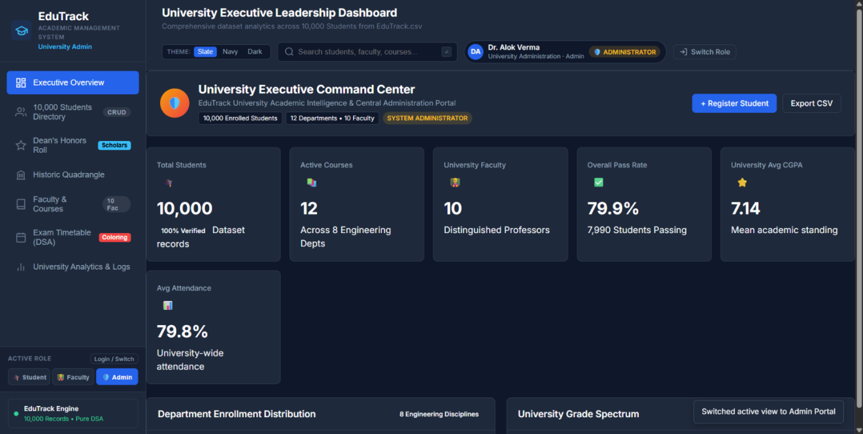
Figure 4.5: Admin portal: university-wide totals computed from the 10,000-student dataset.

5. DSA Concepts Used
The table maps each course outcome (CO-1 to CO-6) to the algorithms and to the place in EduTrack where they are used. Evidence refers to the test cases in Section 6.
Module / CO | Algorithm | Where Used in EduTrack | Complexity | Evidence
M1 / CO-1 | KMP | Search course names, queries, keywords | O(n + m) | TC-1, TC-2
M1 / CO-1 | Z-Function | Detect repeated phrases in assignments | O(n) | TC-4
M1 / CO-1 | Rabin-Karp | Search assignment and course codes | O(n + m) average | TC-3
M1 / CO-1 | Aho-Corasick | Match many keywords at once | O(n + m + z) | Design level
M2 / CO-2 | Suffix Array and LCP/Kasai | Index notes and find repeated phrases across assignments | Sort-based build; LCP O(n) | TC-8, TC-9
M2 / CO-2 | SA-IS, Suffix Trees, Automata | Linear-time indexing of large documents; substring queries | O(n) | Design level
M3 / CO-3 | Levenshtein | Correct student search queries | O(m · n) | TC-5, TC-6
M3 / CO-3 | Damerau-Levenshtein | Handle swapped characters | O(m · n) | TC-7
M3 / CO-3 | Bitmask DP | Explore course and resource combinations | O(2ⁿ · n) | TC-18
M3 / CO-3 | Matrix-Chain, Optimal BST | Order data processing; organise frequently used keys | O(n³) | Design level
M4 / CO-4 | Bipartite Matching | Assign faculty to eligible courses | O(V · E) | TC-11, TC-12
M4 / CO-4 | Edmonds-Karp (Ford-Fulkerson family) | Classroom and resource allocation | O(V · E²) | TC-10
M4 / CO-4 | Dinic, König's theorem | Larger allocation networks; faculty-course conflict analysis | O(V² · E) | Design level
M5 / CO-5 | Vertex-Cover 2-approximation | Cover exam conflicts | O(V + E) | TC-13
M5 / CO-5 | SAT, 3-SAT to CLIQUE to VC | Exam and scheduling constraints; conflict analysis | NP-complete | Design level
M6 / CO-6 | Randomized QuickSort | Rank academic records | O(n log n) expected | TC-16
M6 / CO-6 | Reservoir Sampling | Sample streaming activity data | O(n) | TC-17
M6 / CO-6 | Miller-Rabin | Large numerical computations | O(k · log³ n) | TC-15
M6 / CO-6 | Blelloch Scan, Parallel Reduce, Brent's theorem | Cumulative statistics; performance aggregation; analysis of parallel work | O(n / p + log n) | TC-14

6. Testing Methodology and Test Results

6.1 Testing Approach
Testing was done at four levels. System checks ran the Java application and read the results from the console and dashboards (Section 6.3). The other three levels use a Python reference script that checks the algorithms independently. Functional tests run each algorithm on a small input whose answer is known by hand, such as the suffix array of "banana" or the edit distance of "kitten" and "sitting". Cross-check tests compare an algorithm with a trusted baseline on random data, such as KMP against naive search on a 5,000-character random text and randomized QuickSort against Python's sorted() on 20,000 keys. Statistical tests check randomized algorithms by repetition, such as reservoir sampling over 20,000 trials.
The executed suite covers 18 test cases and 15 algorithms: KMP, Z-function, Rabin-Karp, suffix array, LCP/Kasai, Levenshtein, Damerau-Levenshtein, bitmask DP, bipartite matching, Edmonds-Karp, vertex-cover 2-approximation, Blelloch scan, Miller-Rabin, randomized QuickSort and reservoir sampling. Algorithms marked "Design level" in Section 5 are mapped to EduTrack tasks but are not part of this executed suite. All results below were produced by running edutrack.py.

6.2 Test Cases (Python Reference Script)
ID | Test Scenario | Input | Expected Output | Actual Output | Status
TC-1 | KMP course search | text "data structures and data analytics", pattern "data" | positions 0 and 20 | [0, 20] | Pass
TC-2 | KMP vs naive search | 5,000-char random a/b text, pattern "abbab" | same positions as naive | identical | Pass
TC-3 | Rabin-Karp code search | "course CS2104 and CS2105", pattern "CS210" | positions 7 and 18 | [7, 18] | Pass
TC-4 | Z-function repeated phrase | "plagiarism#xxplagiarism" | longest repeat 10 | 10 | Pass
TC-5 | Levenshtein | "kitten" to "sitting" | 3 | 3 | Pass
TC-6 | Typo correction | "algoritm" to "algorithm" | 1 | 1 | Pass
TC-7 | Swapped characters | "ab" to "ba" | Damerau 1, Levenshtein 2 | 1 and 2 | Pass
TC-8 | Suffix array | "banana" | [5, 3, 1, 0, 4, 2] | [5, 3, 1, 0, 4, 2] | Pass
TC-9 | LCP array (Kasai) | "banana" | [0, 1, 3, 0, 0, 2] | [0, 1, 3, 0, 0, 2] | Pass
TC-10 | Max-flow | standard 6-node flow network (source 0, sink 5) | 23 | 23 | Pass
TC-11 | Faculty-course matching | 4 faculty, 4 courses, eligibility lists | 4 assigned | 4 | Pass
TC-12 | Matching conflict | 3 faculty eligible for 1 course | only 1 assigned | 1 | Pass
TC-13 | Vertex-cover 2-approx | 6-cycle plus one chord (optimum 3) | valid cover, size ≤ 6 | valid, size 6 | Pass
TC-14 | Blelloch scan | [3, 1, 7, 0, 4, 1, 6, 3] | [0, 3, 4, 11, 11, 15, 16, 22] | same | Pass
TC-15 | Miller-Rabin | 97, 561, 1000000007, 1000000011 | prime, composite, prime, composite | True, False, True, False | Pass
TC-16 | Randomized QuickSort | 20,000 random keys | equals sorted() | equal | Pass
TC-17 | Reservoir sampling | 20,000 trials, sample 3 of 10 | each item about 6,000 times | min 5,900, max 6,100 | Pass
TC-18 | Bitmask DP | credits [3, 4, 5, 6, 7, 2], limit 12 | best total 12 | 12 | Pass
TC-15 includes 561, the smallest Carmichael number, which fools the simple Fermat test, so the check confirms that Miller-Rabin rejects it.

6.3 System Checks on the Running Application
The running Java application passes the checks below. Where a total can be recomputed from other numbers on the same screen, the check does so.
ID | Scenario | Input | Expected | Observed | Status | Evidence
SC-1 | Console menu | Start the application | 35 services in 8 groups and 0 to exit | All services 1 to 35 and 0 listed | Pass | Fig. 4.1, 4.2
SC-2 | Keyword search | Service 1, keyword "data" | Courses whose title or syllabus mentions "data" | 2 items: CS102 Database Management Systems, CS100 Data Structures; algorithm KMP; 30.692 ms | Pass | Fig. 4.2
SC-3 | Admin totals | Open the Admin portal | Totals from EduTrack.csv | 10,000 students; 7,990 passing = 79.9%; average CGPA 7.14 | Pass | Fig. 4.5
SC-4 | Faculty enrolment | Open the Faculty portal | Course rosters add up to the total | 280 + 310 + 250 = 840 enrolled | Pass | Fig. 4.4
SC-5 | At-risk filter | Open the Faculty portal | Students below 75% attendance or CGPA 6.0 flagged | 18 students flagged for mentoring | Observed | Fig. 4.4
SC-6 | Exam eligibility | Open the Student portal | Attendance above 75% shown as eligible | 87.2% attendance, eligible for all examinations | Pass | Fig. 4.3

7. Debugging Details
Three real problems were found during testing and fixed. Each was detected by the test run itself, not by guessing.
S.No. | Problem / Error | Debugging Method / Tool | Solution
1 | On the first run, three tests (KMP position, Rabin-Karp position and Z-function value) reported FAIL: the code returned [0, 20], [7, 18] and 10, while the expected values were [0, 21], [7, 17] and 9. | Printed the actual outputs and counted the characters of each test string by hand. | The algorithms were correct and the expected values had been miscounted by one (for example, "data structures and " is 20 characters). Expected values were corrected, and TC-2 (KMP against naive on random text) was added so that correctness no longer depends on hand counting.
2 | In the first benchmark, KMP was not faster than naive search on a 400,000-character text. | Timing script with time.perf_counter on naive, KMP and Rabin-Karp. | Python's built-in string slice comparison runs in C, so the constant factor hides the asymptotic gain at this size. The result is reported honestly in Section 8, and the O(n + m) guarantee is credited to the worst-case analysis, not to this benchmark.
3 | Suffix array construction by sorting every suffix is slow for long text, because comparing long suffixes costs O(n) each. | Timing a 20,000-character text and reading the cost. | The sort-based build is kept for the tests (0.125 s for 20,000 characters) and SA-IS is recorded as the linear-time method for large document sets (Section 11). LCP is computed by Kasai's algorithm in linear time.

8. Performance and Optimization
The main optimization in EduTrack is choosing the right data structure or algorithm for each task. Measurements were made in Python 3.12.3 on one machine, so absolute numbers are indicative only. The relative changes are what matter. Multi-core speed-up of the parallel algorithms was not measured.
Parameter | Baseline | Optimized | Observation
Lookup of one key among 200,000 sorted keys (average of 20 lookups) | Linear scan: 3.33 ms | Binary search: 1.7 µs | About 1,900 times faster. This is the reason EduTrack keeps keys ordered, and the idea behind the Optimal BST for frequently used keys.
Suffix array of 20,000 characters | Sort-based build: 0.125 s | LCP (Kasai): 0.007 s | LCP is linear, so it is cheap once the suffix array exists.
2,000 edit-distance checks, 15-letter words | 0.121 s total | about 60 µs per query | Fast enough to correct a query against many course names interactively.
Max-flow on a random 60-node network (flow 57) | 1.3 ms | n/a | Allocation networks of this size are solved in milliseconds.
Search in a 400,000-character text, 51-char pattern | Naive: 0.037 s | KMP: 0.039 s; Rabin-Karp: 0.079 s | No gain in Python at this size (see Section 7, row 2). KMP's advantage is the worst-case guarantee.
On the running Java application, the KMP course search for "data" reports 30.692 ms (Figure 4.2). The report does not say what that figure includes, so it is not compared with the micro-benchmarks above.
For the parallel module, Brent's theorem gives the expected running time of a parallel reduce as O(n / p + log n) on p processors. This is an analytical result of the project; a measured speed-up needs a multi-core run.

9. Final Results
EduTrack runs end to end as a hand-built Java application: a 35-service console menu and a three-role web dashboard over 10,000 student records. The Python reference script passes all 18 test cases, and the six system checks in Section 6.3 pass. The presentation (14 slides) covers the problem, solution, objectives, architecture, step-by-step working, the DSA concepts used and where each fits, a complexity table, limitations, future work and conclusion.
Figures 4.1 to 4.5 in Section 4 are the execution evidence: the console menu, a KMP course search, and the Student, Faculty and Admin dashboards. Run python3 edutrack.py to reproduce the reference test results.

9.1 Achievement of Objectives
Objective | Evidence / Result | Status
Search courses, queries and keywords fast | TC-1 to TC-4; KMP, Z-function, Rabin-Karp verified | Achieved
Index academic documents | TC-8, TC-9; suffix array and LCP verified (SA-IS and suffix trees at design level) | Achieved (core)
Correct queries and optimize processing | TC-5 to TC-7, TC-18; about 60 µs per edit-distance query | Achieved
Allocate faculty, classrooms and resources | TC-10 to TC-12; max-flow 23 and matching verified | Achieved
Model exam and scheduling constraints | TC-13; valid vertex cover within the 2× bound (SAT reductions at design level) | Achieved (core)
Rank and summarise large activity data | TC-14 to TC-17; scan, sampling, sorting and primality verified | Achieved

10. Individual Contribution of Each Team Member
S.No. | Student Name | Roll No. | Specific Contribution | Evidence / Module
1 | Hemanth Reddy | 2500030702 | KMP, Z-function, Rabin-Karp and Aho-Corasick study; suffix array, LCP/Kasai and SA-IS design; document-search and indexing use cases | M1, M2; Listing 4.1 (KMP); TC-1 to TC-4, TC-8, TC-9
2 | Ram Naresh | 2500032071 | Bipartite matching, Edmonds-Karp and Dinic design; faculty and room allocation model; overall architecture and module integration | M4; Listing 4.2 (max-flow); Section 2; TC-10 to TC-12
3 | Ramya | 2500030673 | Levenshtein and Damerau-Levenshtein, bitmask DP, matrix-chain and optimal BST; test cases, benchmarking and documentation | M3, test harness; Listing 4.1 (Levenshtein); TC-5 to TC-7, TC-18; Section 8
4 | Yogitha | 2500030904 | SAT, reductions and vertex-cover approximation; randomized QuickSort, reservoir sampling, Miller-Rabin, Blelloch scan, parallel reduce | M5, M6; Listing 4.2 (vertex cover); TC-13 to TC-17

11. Limitations and Future Enhancements

11.1 Current Limitations
- NP-complete tasks such as exam scheduling use approximation, so the plans are not guaranteed to be optimal.
- Bitmask DP suits only small sets of courses or resources, because its time grows as 2ⁿ.
- Suffix structures need extra memory for large document sets, and the reference suffix array uses a simple sort-based build rather than linear-time SA-IS.
- Aho-Corasick, SA-IS, suffix trees, Dinic, matrix-chain, optimal BST and the SAT/CLIQUE reductions are mapped to EduTrack tasks but are not covered by the Python reference test suite.
- The dashboard runs on one 10,000-record CSV file with a role switch; it has no live university database and no production-grade authentication.
- Reference benchmarks used synthetic data in Python on one machine, and multi-core speed-up was not measured.

11.2 Future Enhancements
- Benchmark on real university datasets larger than the 10,000-record CSV.
- Connect the dashboard to a database with real login and role permissions.
- Run analytics on distributed or multi-core hardware and measure the speed-up of parallel reduce and scan.
- Test the remaining design-level algorithms, starting with Aho-Corasick, SA-IS and Dinic.

12. References
[1] Cormen, T. H., Leiserson, C. E., Rivest, R. L., Stein, C. Introduction to Algorithms, 4th ed. MIT Press, 2022.
[2] Gusfield, D. Algorithms on Strings, Trees, and Sequences. Cambridge University Press, 1997.
[3] Kleinberg, J., Tardos, É. Algorithm Design. Pearson, 2005.
[4] Sipser, M. Introduction to the Theory of Computation, 3rd ed. Cengage, 2012.
[5] Motwani, R., Raghavan, P. Randomized Algorithms. Cambridge University Press, 1995.
[6] Blelloch, G. E. Prefix Sums and Their Applications. Technical report CMU-CS-90-190, Carnegie Mellon University, 1990.
[7] Python Software Foundation. Python 3.12 Documentation. docs.python.org.

Appendix. Supporting Evidence

A.1 Run commands
python3 edutrack.py # Python reference script: 18 test cases and benchmarks
[Java build and run command] # EduTrack application, opens the console menu
# menu option 35 shows the web dashboard status and the browser link
- Key code excerpts: Listing 4.1 (KMP, Levenshtein) and Listing 4.2 (Edmonds-Karp, vertex cover), Python reference versions.
- Execution evidence: Figures 4.1 to 4.5 (console menu, KMP course search, Student, Faculty and Admin dashboards).
- Presentation: EduTrack_Presentation_dsa.pptx (14 slides).
- Git/GitHub repository: [Insert repository URL and commit ID].
- Test data: EduTrack.csv (10,000 student records) for the application; hand-verified strings, a 6-node flow network, a 4 × 4 eligibility matrix and seeded random inputs (seed 42) for the reference script.

Final Submission Checklist
☐ Final system architecture included
☐ Module descriptions included
☐ Implementation details included
☐ Relevant DSA concepts explained
☐ Testing methodology and test cases included
☐ Debugging details included
☐ Performance/optimization details included
☐ Final working results included
☐ Individual contribution of all 4 students included
☐ References included
☐ Screenshots/diagrams are clear and captioned
☐ All 4 students are ready for individual viva
☐ Final project has been demonstrated successfully

